**How to Run code in Ubuntu:**

1. **Open a terminal window.**

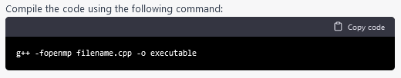

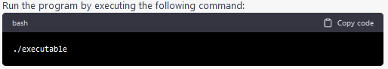

**Output**

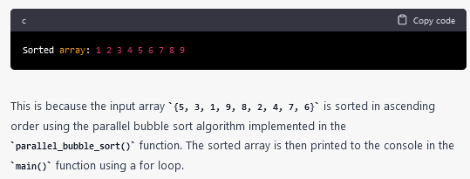

**To measure the performance of sequential Bubble sort and parallel Bubble sort algorithms, you can follow these steps:**

1. Implement both the sequential and parallel Bubble sort algorithms.
2. Choose a range of test cases, such as arrays of different sizes and different degrees of sortedness, to test the performance of both algorithms.
3. Use a reliable timer to measure the execution time of each algorithm on each test case.
4. Record the execution times and analyze the results.

When measuring the performance of the parallel Bubble sort algorithm, you will need to specify the number of threads to use. You can experiment with different numbers of threads to find the optimal value for your system.

Here are some additional tips for measuring performance:

* Run each algorithm multiple times on each test case and take the average execution time to reduce the impact of variations in system load and other factors.
* Monitor system resource usage during execution, such as CPU utilization and memory consumption, to detect any performance bottlenecks.
* Visualize the results using charts or graphs to make it easier to compare the performance of the two algorithms.

**How to check CPU utilisation and memory consumption in ubuntu**

In Ubuntu, you can use a variety of tools to check CPU utilization and memory consumption. Here are some common tools:

1. top: The top command provides a real-time view of system resource usage, including CPU utilization and memory consumption. To use it, open a terminal window and type top. The output will display a list of processes sorted by resource usage, with the most resource-intensive processes at the top.
2. htop: htop is a more advanced version of top that provides additional features, such as interactive process filtering and a color-coded display. To use it, open a terminal window and type htop.
3. ps: The ps command provides a snapshot of system resource usage at a particular moment in time. To use it, open a terminal window and type ps aux. This will display a list of all running processes and their resource usage.
4. free: The free command provides information about system memory usage, including total, used, and free memory. To use it, open a terminal window and type free -h.
5. vmstat: The vmstat command provides a variety of system statistics, including CPU utilization, memory usage, and disk activity. To use it, open a terminal window and type vmstat.